How to fix MacBook not powering on or stuck on Blank Display.

What are the causes of this issues

* Faulty power cord
* USB-C charging port
* Battery gets dried
* Firmware related issue.
* Display backlight issue.

Basic Troubleshooting Steps to follows:

* Check whether charging cable is damage.
* Ensure that MacBook MagSafe USB-C charging port is correctly getting fitted inside jack.
* Check Power adapter getting overheat. If yes then check with another power adapter.
* Tried to reset MacBook PRAM (Primary RAM) and SMC (System Management controller)

How to reset PRAM :

* Press this all buttons Command, P,R, option for at least 10 second and release all key at same time.
* Now your MacBook should power on normally, if there is only issue with RAM.



How to reset SMC :

* Disconnect your MacBook from plugged in charger.
* Hold left shift + Control + Option and power button for 10 seconds
* Re-Connect charger and press this all above again for 10 Seconds
* Then continuously long press power button until your MacBook display Apple logo.

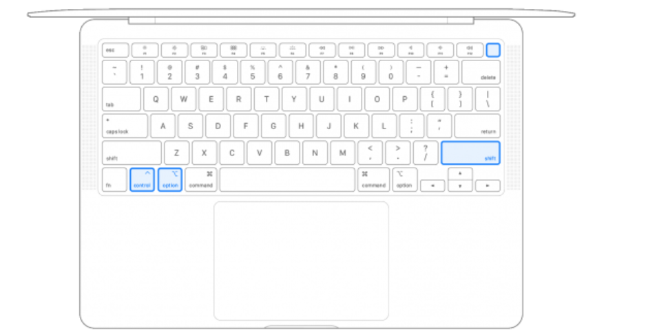

**Why/When to Revive or Restore MacBook**

If the firmware stored in its memory needs to be revived or restored, a Mac with Apple silicon or the Apple T2 Security Chip might become unresponsive. This can occur in certain rare circumstances, such as when a power failure interrupts macOS installation error like Folder? Error, exclamation error, etc.

**What are the requirement to revive or restore MacBook**

* **Working MacBook with Apple Configurator Tools (**Download and Install this from AppStore or Apple official website) **using (MacOS Monterey 12.4 or later macOS)**
* **Apple USB-C to USB-C charging cable.**

**Steps to process revive and restore Mac:**

1. **(On Affected MacBook Pro series of 2018 till 2020 & 2021 or later M1, M2, M3 and M4 series)**
2. Plug this MacBook to charge.
3. Mac with Apple silicon (M1, M2)

plug the USB-C cable into the leftmost USB-C port.

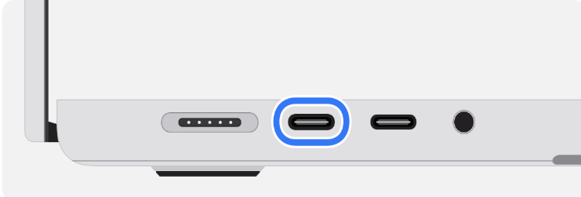

Mac with T2 chip (Intel based Mac):

plug the USB-C cable into the rightmost USB-C port.



**2. (On other or host MacBook Pro series of 2018 till 2020 & 2021 or later M1, M2, M3 and M4 series)**

1. Plug this MacBook to charge.
2. Plug other end of the USB-C cable into any USB-C port.
3. Make sure this MacBook is connected with internet via Wifi or LAN network.

1. **(On Affected MacBook Pro series of 2018 till 2020 & 2021 or later M1, M2, M3 and M4 series)**
2. Press and hold the power button for 10 seconds.
3. Press and release power button, then immediately press and hold all four keys together to put this Mac in DFU (Device Firmware Utility) mode

Control ⌃ on the left side of the keyboard

Option ⌥ on the left side of the keyboard

Shift ⇧ on the right side of the keyboard

Power button

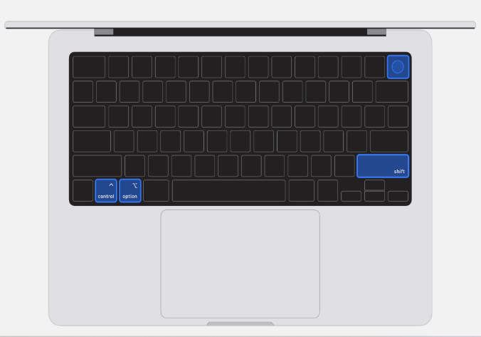

Note: 1) Mac with Apple silicon chip (M1): Keep holding all four keys for about 10 seconds, then release all keys except the power button. After about 3 seconds, release the power button.

2) Mac with T2 chip: Keep holding all four keys for about 3 seconds, then release all keys.

1. **Then new window will be pop-up and your affected MacBook will be now ready to revive or restore Firmware update from Apple Configurator Tool.**

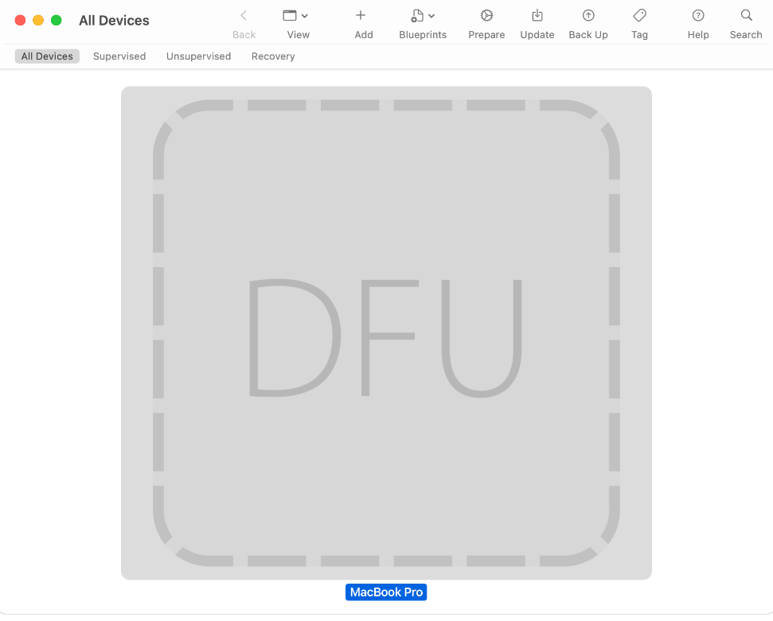

1. Click Actions> Advanced> Revive Device.

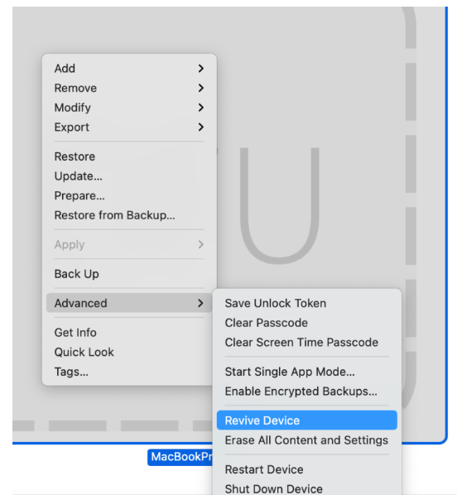

Note: Revive will reinstall macOS Recovery on your Apple Silicon Mac. This option retains user data.

Or

1. Click Actions> Restore option

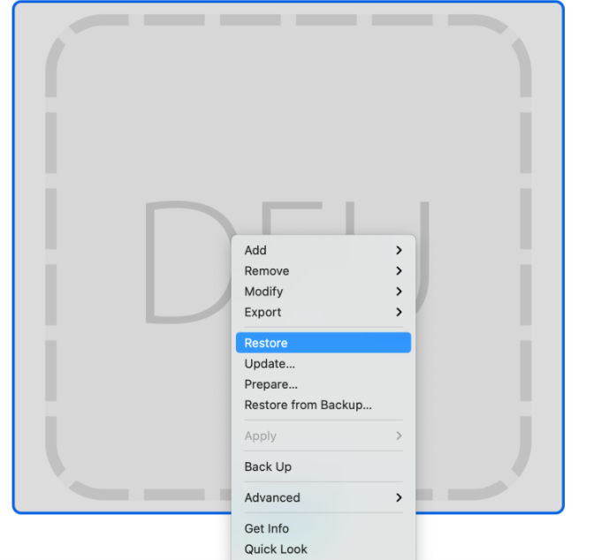

Note: Restore option – **Reinstall macOS Recovery, ERASE your SSD hard drive and reinstall macOS**.

1. You will now see a warning message. Do you want restore “MacBook Pro” to it’s Factory settings and latest firmware version?

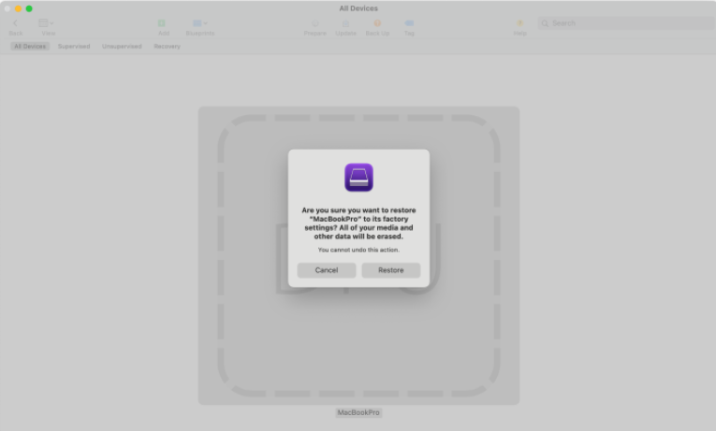

1. You can select Restore to erase your drive and reinstall macOS. The process will only take about 15 minutes.

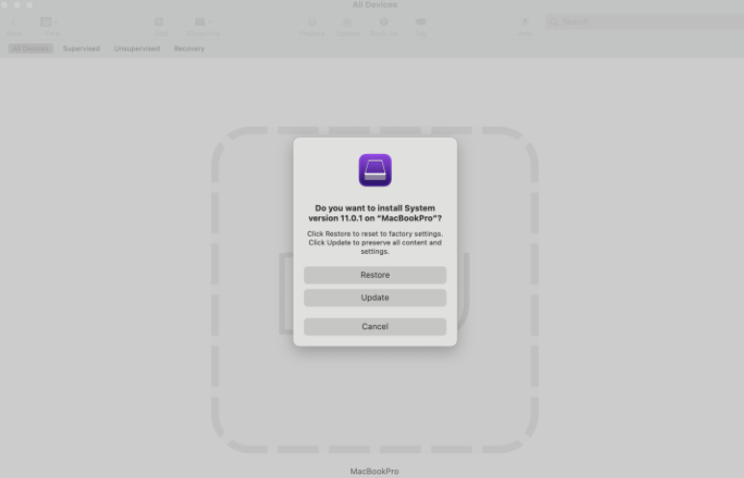

1. Reviving process get start.

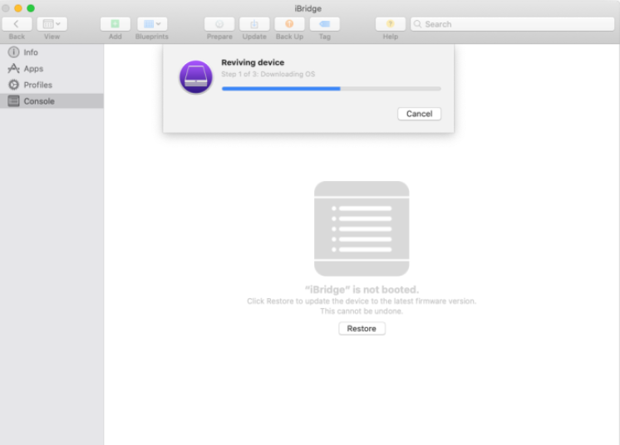

1. Unzipping MacOS



1. Installing MacOS.

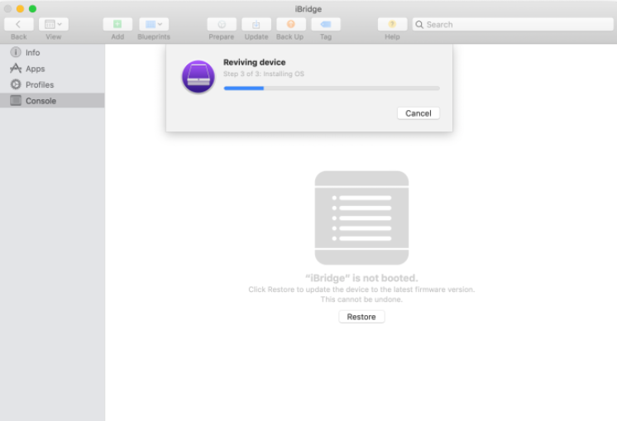

This process will take time and your issue will be resolved.

Done……